Performance Committee 2nd September 2016 – City Deal Chair’s Briefing Note

Purpose of Briefing Note

The purpose of this Briefing Note is threefold:-

- This first part of this briefing note provides a background summary on City Deal financial, governance and programme management arrangements along with a brief summary of the City Deal performance in the first 2 years.

- The second part of the note briefly summarises the work of the initial phases of the City Deal Resources Review currently underway alongside highlighting a number of arrangements already established to continuously challenge assumptions (in relation to delivery, cost and income) made at the outset of the City Deal.

- The third part of the note proposes a scope and methodology for further phases of the Resources Review for discussion and consideration with the Performance Committee.

1. Background

Context
The City Deal which comprises a 10 year programme was signed by Government and the three Councils (South Ribble, Preston and Lancashire) in 2013. The first year of implementation was 2014/15. The core principle of the City Deal is that the Councils and Government (via the Homes and Communities Agency - HCA) collectively pool their resources to facilitate the delivery of an agreed set of infrastructure priorities to create new homes (Circa 17,500) and jobs (Circa 20,000) in Central Lancashire.

Financial
The City Deal in underpinned by an Infrastructure Delivery Fund (£334M) which is split into two sections – resources, (ie, income received/forecast to be received into the fund) and delivery programmes, (ie, expenditure paid/forecast to be paid on infrastructure schemes). Income is derived from: New Homes Bonus, Community Infrastructure Levy, business rates, local authority capital receipts, HCA loan and grant from land sales and developer contributions such as s278 monies. The City Deal is an accelerated delivery model based on the premise that the timing of resources coming into the model will be behind expenditure on schemes, (requiring cash flow support from the County Council). There is a commitment of the partners to keep the model balanced and to mitigate potential cost overruns. The model is dynamic and reflects changes to inputs and outputs of the model occurring over time. This is sustainable subject to County Council maximum cash flow approvals being in place and not breached.

Governance
The City Deal Executive, chaired by LEP Director Jim Carter, and the City Deal Stewardship Board, chaired by HCA NW Regional Director, Deborah McLaughlin form the two principal governance structures guiding the City Deal. Since 2014 the Executive and Stewardship Board have met on a quarterly basis in a combined format. There are a number of operational boards and groups that sit beneath this governance structure.

Programme Management
The primary role of the City Deal Executive and Stewardship Board – E&SB – is to agree and oversee the implementation of an annual Infrastructure and Delivery Plan and the HCA Business and Disposal Plan, and to monitor achievement of the housing and employment outputs. Core and secondary outputs and annual targets are agreed with Government with monitoring reports prepared for Government every 6 months.

The diagram below sets out current programme management arrangements.

Performance
In the first 2 years of the City Deal (14/15 – 15/16 implementation of the infrastructure schemes proceeded at pace and in line with the targets and milestones set out in the Infrastructure and Delivery Plan and core housing and employment targets were all met.
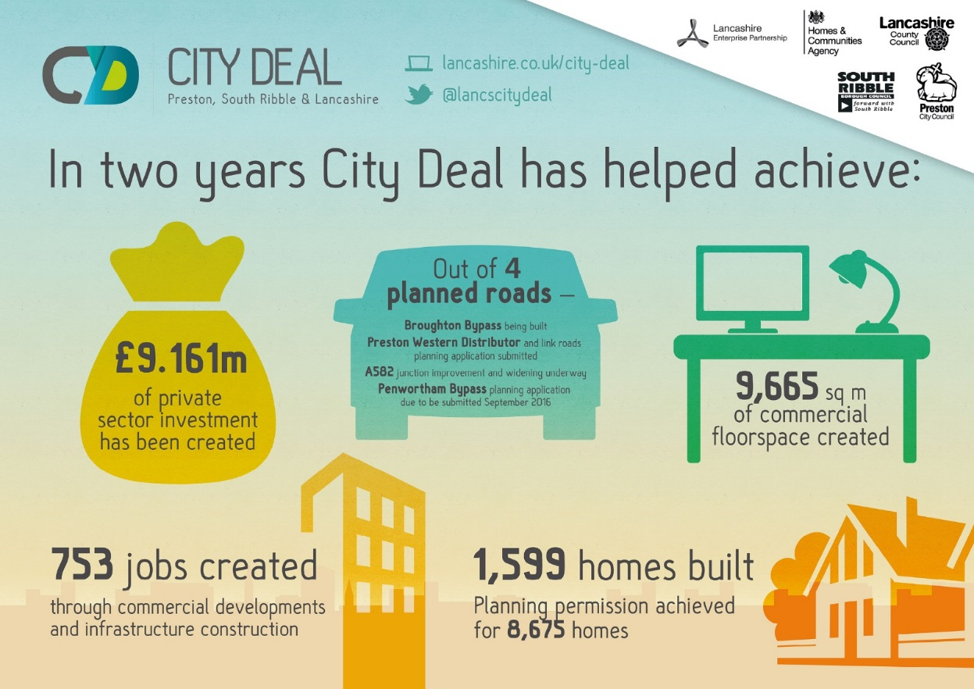
This has provided the LEP with a strong evidence based record of achievement and delivery upon which to build its relationship with Government and to assist in its case-making for Growth Deal and other devolved arrangements.
2. Continuous Improvement
Whilst a solid start to the City Deal has been made, the E&SB recognises that this is a long-term initiative of the scale and complexity that requires robust and well-resourced project and programme management. This will ensure that the relevant projects are delivered within an efficient manner and that delivery challenges and pressures on income and costs are overcome. It is anticipated that the delivery challenges and pressures on income and costs will scale up over time as the City Deal moves from the first 2-3 years of preparation and works on a number of the larger projects commence. In recognition of this the E&SB agreed to the following:-

- In Summer 2014, to hold annual away days to review the progress, to understand emerging challenges and to review governance, the first away day took place in Autumn 2015, with the next session being scheduled for Winter 2016;
- In Autumn 2015, to undertake a Resources Review, with support from external advisors Keppie Massie and chaired by Jim Carter, focussing on City Deal income streams potentially impacted upon by changes to Government policy, and the pace of housing delivery – a direct driver of City Deal income;
- In Winter 2015, to ask UCLAN and Chorley Borough Council to attend City Deal E&SB meetings, initially as observers. UCLAN attended their first meeting in June 2016 in this capacity and Chorley have agreed to attend from September 2016;
- In Winter 2015, and as part of the LEPs wider marketing activity, to ask the Chief Executive of Marketing Lancashire (ML) to provide strategic marketing support and advice. The Chief Executive of ML now attends all E&SB meetings as well as inputting into the communications and marketing group; and
- In Spring 2016, to work with the Performance Committee to provide assurance with regard to the delivery of major City Deal highways infrastructure.

Resources Review - Income: In Autumn 2015 it was evident that the Government were proposing potential changes to three important sources of City Deal income: New Homes Bonus (NHB); Community Infrastructure Levy (CIL); and business rates (NNDR). At the time the City Deal was signed it was understood by the Councils and by Government that the City Deal Infrastructure Delivery Fund (IDF) was dependent on these income streams and the City Deal agreement therefore acknowledges that local partners and Government will review the Deal should changes be made by Government to these funding streams. Following informal discussions with civil servants, the E&SB agreed to use external consultants, Keppie Massie, to help advise on the potential impact on proposed changes. “Phase 1” of the Resource Review (RR) commenced and concluded that it was not possible at this stage to robustly quantify the impact of potential changes to NNDR or CIL (given that potential policy changes were insufficiently crystallised to enquire as to the potential financial implications) and with regard to NHB that the IDF would be negatively impacted upon by between £9M and £32M. The E&SB considered a report on these findings at its meeting in May and agreed that it would be prudent to await Governments pronouncement on the level of NHB changes before commencing formal negotiations with Government regarding the IDF deficit. In June the EU Referendum fundamentally changes the political landscape in the UK resulting in the departure of the Prime Minister and Chancellor. Given potential inertia as a result of these political changes, the summer break, economic uncertainty and immediate Government priorities no announcements (or indications as to a likely timescale) by Government have yet been made on NHB.

Resources Review – Housing Delivery In parallel with the extensive work undertaken with regard to testing the assumptions and ongoing certainty of City Deal income streams the RR has also been considering, as “Phase 2” , the ability to deliver the quantum of new housing within the 10 year City Deal Period. As well as being a direct and quantifiable output of the City Deal new homes also provide two income streams into the City Deal – CIL and NHB. The E&SB in June considered a report by KM which set out the findings of an extensive analysis by KM, based on one to one meetings with the main house-builders active in the City Deal area, detailed discussions with the LPAs and KMs own industry knowledge. This analysis provisionally concludes that the mobilisation period for the house builders has been longer than anticipated and that full delivery of the 17,500 could take up to 15 years to complete, with the infrastructure programme remaining as a 10 year delivery programme. Since this analysis was undertaken the Government have made further policy announcements with regard to the HCA undertaking “direct delivery” of housing and the impact of this on the City Deal is currently being evaluated – it is possible that this could increase the number of houses capable of being delivered in the 10 year original period. The analysis by KM also demonstrates that without a City Deal the scale of house building in Central Lancashire would be significantly under that being achieved and forecast with a City Deal, as set out below.

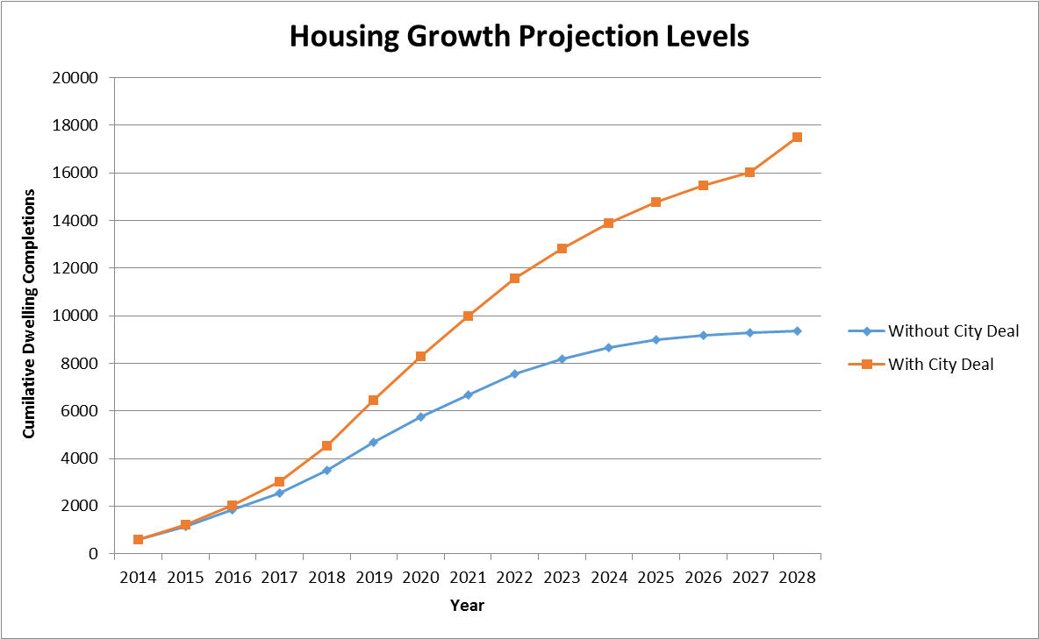

Resources Review – Commercial Site Delivery As part of the Phase 2 instructions KM are currently undertaking an evaluation on the assumptions made at the outset of the City Deal with regard to the scale of the commercial sites in the City Deal and the timescales within which they can be delivered. The job numbers set out in the City Deal are a direct function of the commercial floor-space created and new commercial sites provide two key income streams to the City Deal – NNDR and CIL. The KM evaluation, which includes one to one discussions with developers and land-owners active in the City Deal area, as well as detailed discussions with the LPAs and KMs own industry knowledge will be completed in mid- September.

Phases 1 and 2 of the Resources Review will be concluded in September with a final report being considered by the E&SB at its meeting on 31st September. This will set out the position pre EU referendum but will acknowledge the need, specifically with regard to pace of housing delivery, to continue to review and monitor market conditions post EU Referendum as the full economic impact of the UK’s decision to leave the EU becomes known.

Resources Review – Costs
Given the potential Government changes to income streams, the RR has, so far, been focussed on certainty of income and site delivery. However, assurance that the City Deal infrastructure schemes are affordable within the City Deal IDF and that costs are being controlled is vital. It should be noted that the Infrastructure costs set out in the original City Deal agreement were based on provisional estimates. If negotiation with Government with regard to Government changes to City Deal income streams is to take place Government will need to be reassured that cost liabilities are being managed. Furthermore, the County Council will need to be reassured that the cash flow approvals are not breached due to cost increases. In recognition of this the E&SB approved, in March 2016, a process to ensure final costs of infrastructure costs are approved and schemes are fully funded prior to implementation. (NB, Broughton Bypass and Preston Western Distributor (were/is) already subject to TfL and LEP approval via the Growth Deal process)

Design and Delivery of Infrastructure Schemes
Since the outset of the City Deal a “mixed economy” approach has been taken to the design and delivery of infrastructure schemes. The County Council, in its capacity as local Highway Authority, does have expertise in designing and delivering infrastructure schemes as well as working with private sector delivery contractors. For example:-

- The dualling of the A582 has been designed and delivered by the County Council;
- The Broughton Bypass has been designed by the County Council and is being delivered by Hochtief; and
- The Preston Western Distributor is being designed by the County Council with early contractor engagement by Costain

This mixed economy approach has merits and the use of the County Council to date has allowed City Deal projects to “hit the ground running” and to be essentially fast-tracked so that local partners and the LEP have been able to demonstrate tangible and active delivery progress immediately after the City Deal was signed. In the case of design, it has also provided the mechanism through which the quality of the design in terms of satisfying the County Council in its capacity as highway authority that it will deliver a highway than can be adopted and thereafter maintained at the public expense, can be tested from the outset. However it remains important for the E&SB to continue to challenge and test proposed design and delivery models in order to achieve the best outcomes for the City Deal. In recognition of this the Chair, at the September meeting of the E&SB, will propose that for programme critical infrastructure schemes the E&SB be asked to consider and make decisions on the design and delivery model i.e. direct delivery by the County Council or whether to tender the relevant scheme. The E&SB will, thereafter, make recommendations to the County Council regarding design and delivery routes.

Programme Critical Implementation
The E&SB consider detailed quarterly progress and monitoring reports on the Infrastructure and Delivery Plan and on the HCA Business and Disposal Plan. It is inevitable, on a programme of the scale and complexity of the City Deal that project delays across all areas (infrastructure schemes, and housing and commercial sites) will occur. It is important for the E&SB to be advised as to where those delays could affect whole City Deal programme delivery and at the request of the E&SB in May programme critical issues emerging on the projects and development sites are now reported separately to the E&SB in addition to being flagged in the quarterly monitoring reports. A delay on Broughton Bypass, one of 4 key City Deal infrastructure projects was reported to the Executive in May 16 which highlighted a need for project managers to report emerging issues in a timely manner and the introduction of additional explicit quarterly monitoring questions.

The E&SB established a task and finish planning and housing delivery working group to review the processes already in place to provide assurance that housing sites are being brought forward in the most expedient way. This group has concluded its initial work and the E&SB will consider a report of the group at its September meeting. This report will highlight the need for a more development management approach to be taken, specifically with regard to the scale and timing of the input from statutory agencies, including the County Council, pre and post planning application submission.

“What Next” for City Deal
In considering a range of mitigation measures to respond to the challenges to income streams, and the pace of housing delivery, the E&SB have taken the opportunity to look forward, over a 15-year horizon, to the Place of Central Lancashire. This has included, for example, presentations on the potential for a redeveloped railway station in Preston, potential for Garden Village proposals, Direct Delivery of housing by the HCA, the impact of the Governments Starter Homes policy in the area, the role UCLAN can play in the local area and a strengthened City Deal inward investment offer.

The E&SB has overseen detailed and valuable work with regard to certainty of income and has put in place a number of measures to seek to control cost and manage programme challenges. However, given the scale of these challenges is likely to increase over the life-time of the City Deal, the E&SB would like to undertake further work on these areas and to report back to the Performance Committee in Autumn. The E&SB will also undertake more work to provide assurance to the local partners and the LEP that maximum social value is also being extracted from the significant spending on infrastructure schemes and new housing and commercial sites

3. Resources Review - Phase 3 – Value for Money; Social Value; and Programme Implementation

It is proposed that KM undertake further work in relation to value for money, social value and programme implementation to compliment the work done to date on income and housing and commercial site delivery projections. This work, “Phase 3” will complete the 2016/17 Resources Review and can provide a robust evidence base for the local partners and the LEP to pursue a potentially “refreshed” City Deal proposition with Government. KM have considered the requirements and propose the following methodology and outcomes.

Part I – Keeping Pace with Programme
Part I could be achieved by looking at proposed timetables and checking whether the proposed delivery timetables are in keeping with existing projections or in line with any benchmarking that has been undertaken. Wherever delays have been observed, views will be needed as to whether other organisations would have faced the same problems or whether delays have been caused by reasons specific within the organisation. This will include a review of the findings of the housing and planning working group.

Method of analysis could comprise the following structure:-
Analysis of scheme benchmarks and the suitability of the benchmarks that have been adopted for the purpose of identifying initial delivery timescales.
- If benchmark has been achieved – fine
- If benchmark has not been achieved – issue
In the event that the benchmark has not been achieved, why was this the case, provide recommendations for potential processes and procedures in the future to overcome any identified issues.

Part II – Value for Money
This element will firstly review the robustness of the highline estimates for the main infrastructure schemes which were prepared prior to the City Deal submission in 2013. It is only as schemes progress from concept, outline and final design stage that actual costs are established. This piece of work will reference respective guidance documents including the CLG Document “Best Value Statutory Guidance” in addition to potentially acknowledging “Partnership for Public Procurement” which has been put together by the Chartered Institute of Procurement & Supply (CIPS) and The Institute for Public Procurement (NIGP). Where work has not been competitively tendered KM will discuss matters with the relevant County Council procurement and highway officers to understand how costs have been benchmarked and value for money obtained. Identification of the potential benefits of not procuring external services will also be considered by KM which may include an ability to expedite delivery or to reduce administrative costs by not externally procuring services.
Method of analysis could comprise the following structure:-
Analysis of scheme benchmarks and the suitability of the benchmarks that have been adopted for the purpose of identifying an initial cost. [
- If benchmark has been achieved – fine
- If benchmark has not been achieved – issue
In the event that the benchmark has not been achieved why was this the case, provide recommendations for potential processes and procedures in the future to overcome any identified issues.

Part III – Social Value
Social Value is defined as:-
“A way of thinking about how scarce resources are allocated and used. It involves looking beyond the price of each individual contract and looking at what the collective benefit to a community is when a public body chooses to award a contract”
As part of this instruction KM will liaise with Dr Michele Lawty Jones who is the Lancashire Skills Hub Director, and has worked on the LEP”s Growth Deal Social Value Toolkit.
KM will look at the County Council’s Social Value Policy (which the County Council will have regard to when making procurement decisions) and assess whether the procurement decisions have full regard to this.

Method of analysis could comprise the following structure:-
Is there a Social Value Policy in place within the existing procurement procedures that Officers have regarded to when making decisions as to who to award contracts do?
If yes, comment on:-
- Has this been implemented?
- Has Social Value principle been achieved?
If no, comment on:-
- Should a Social Value Policy be in place, and enshrined within all procurement decisions?
- Identification of potential processes and procedures to ensure that the Social Value objective is achieved, and ensuring that a framework or criteria in place is fit for purpose to ensure that procurement decisions have full regard to this.
- How this has been achieved elsewhere. Local Authority examples?

It is proposed that the conclusions and outputs for the three work areas take the following format.
- Identification of Audit Procedures and Methodology Employed
- Outcomes of Analysis
- Identifications of any Shortcomings
- Mitigations or Alternative Approaches

4. Conclusions
At the end of the first 2 years of implementation of the City Deal all output targets and delivery milestones have been met. The E&SB has already undertaken significant work to better understand pace of housing delivery and challenges to income streams. The E&SB continues to look forward and to focus on the Place of Central Lancashire. The E&SB has put in place a number of checks and balances to control cost and manage programme delivery issues and further work needs to be done to continue to provide assurance on costs, social value and achievement of programme critical milestones. It will also be important to continue to try and estimate the impact of Brexit, particularly on the appetite of local house-builders and developers in the City Deal area. A comprehensive Resource Review report will help the local partners and the LEP have a meaningful negotiation with Government, and the timing of this negotiation needs to be carefully considered and agreed by the LEP and the local partners.

